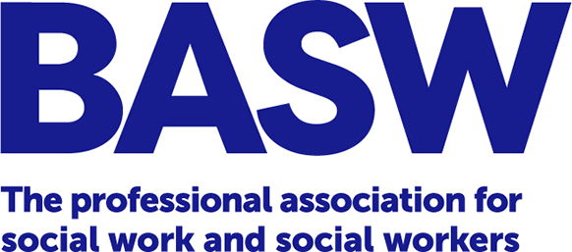

**BRITISH ASSOCIATION OF SOCIAL WORKERS**

**ROLE DESCRIPTION – BASW VICE CHAIR**

**Key accountability:** **To the membership, to Council and to the social work profession**

**Key responsibilities:** To be a Director of the Association, to act as an Honorary Officer of BASW Council supporting the running of the association and supporting the BASW Chair in their duties, deputising when necessary and sharing duties as agreed.

**Main responsibilities**

**In respect of Council**

1. To act as a company Director of BASW, the not-for-profit company, limited by guarantee.
2. To deputise for the BASW Chair and share responsibilities with the Chair as agreed, including chairing Council or other constitutional meetings if the Chair is not available.
3. To be an Honorary Officer, working closely with the Chair, Treasurer and CEO, meeting at agreed frequency, and taking collective responsibility to ensure the smooth running of the association and delivery of the business plan.

**In respect of the Membership**

1. To represent the Association at external and strategic meetings to promote and represent BASW, as agreed.
2. To show leadership in undertaking additional tasks and roles required by Council and the Association.
3. To act as a media spokesperson from time to time.

**In respect of social work and social workers across the UK**

1. To act as a leader in the social work sector, raising the profile and standing of BASW and the profession as a whole.

**In respect of the Association as a whole**

1. To represent and promote the Association at events and external stakeholders’ meetings, in honorary and strategic capacities.
2. To agree with the other Honorary Officers and other Council Directors how external representative responsibilities and formation of relationships may be shared.
3. To be prepared to take on Committee chair or member role/s for BASW as required.
4. Any other relevant and appropriate duties, as required.

Personal requirements

1. To hold a social work qualification recognised in the UK.
2. To have a credible track record in social work practice and/or other aspects of the profession
3. To be willing and motivated to actively promote the social work profession as a whole and all the objects of the Association.
4. To possess excellent writing and verbal skills, including public speaking and presentation skills.
5. To have effective leadership and chairing skills.
6. To be willing to undertake additional tasks and duties required by Council or the Association, by agreement, including to deputise for the Chair of BASW on occasions
7. To take on a leadership role on behalf of Council on themes and priorities, as agreed.
8. To have the ability and willingness to promote social work and the Association publicly and in accordance with agreed policies and messages, including through work with the press and in social and broadcast media.
9. To be committed to BASW’s transformational agenda in respect of Equality, Diversity and Inclusion, involving Experts by Experience and promoting Sustainability of environment and people.
10. To be able to build an effective, productive working relationship with the Chair, Treasurer and CEO of BASW.
11. To be able to secure a time commitment for the work of the Association of about two days per month.

**Appointment & Term of Office**

The Vice Chair will be elected by the whole membership and take office from the conclusion of the BASW AGM and hold office until the conclusion of the 2nd AGM following the one at which they were elected. The Vice Chair can be re-elected for a further 2-year term of office, for up to four consecutive years.

The role is non-executive and the post-holder will be expected to act in accordance with the policies and procedures of the Association.

Remuneration by way of an honorarium of £12,900 p.a. is currently available to the post-holder.

Eligibility

Candidates must have been Members of the Association for a minimum of 2 years continuously immediately prior to the deadline for receipt of nominations and must be in good standing in the Association. BASW is a company limited by guarantee and all candidates must be eligible to stand as company directors as well as meeting the skill, expertise and knowledge requirements of the role.

November 2023