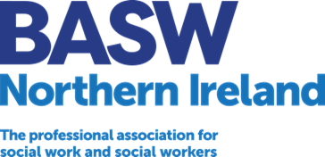

**NORTHERN IRELAND COMMITTEE APPLICATION FORM**

**About you:**

|  |  |
| --- | --- |
| Name: |  |
| BASW Membership No. (if known): |  |
| Job Title: |  |
| Employer: **(if employed)** |  |
| University: **(if applicable)** |  |
| Date of Qualification: |  |

**Contact Details:**

|  |  |
| --- | --- |
| Address |  |
| Postcode |  |
| Email |  |
| **Telephone** |  |

**Areas of Interest/Practice:**

|  |  |
| --- | --- |
| **Please tell us about your areas of interest or practice** |  |

# Select position you wish to stand for:

# Chair Committee Student Representative

# Member

# 

**Experience/Knowledge and Skills:**

|  |  |
| --- | --- |
| **Please provide no more than 500 words about your experience, knowledge and skills.** |  |

**Conflict of interest:**

|  |  |
| --- | --- |
| **Please declare if there is any conflict of interest (commercially or otherwise) in your applying for this post.** |  |

**Have you ever been involved or are you currently involved in a regulatory body conduct hearing?**

Yes No

**Have you ever been sanctioned, suspended or barred from practising social work?**

Yes No

**Have you been convicted for any criminal offences?**

Yes No

**I give consent for my statement of application and my photograph to be included in Northern Ireland Committee election nomination marketing material, should an election be required.**

Yes No

**Declaration:** **I hereby declare that I am eligible for election and will abide by the BASW Code of Ethics for Social Work, BASW Memorandum of Articles and National Standing Committee Terms of Reference.**

**Signature**: ………………………………………………………………………....

**Date** …………………………………………………………………………

Candidates should submit electronically their completed nomination form, together with a passport size head and shoulders colour photograph to [lindsey.bates@basw.co.uk](mailto:lindsey.bates@basw.co.uk)

*‘We encourage members from all communities, identities and backgrounds to consider these roles, particularly those previously less well represented in BASW’s leadership.  BASW Northern Ireland is committed to being more diverse and representative of our membership, sector and society’.*