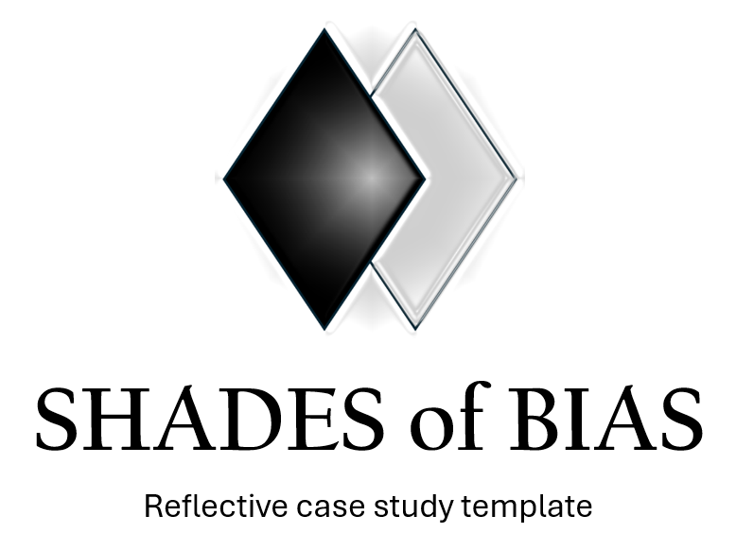

Shades of Bias (SoB) is a case study template designed to help document and analyse discriminatory/oppressive/racist incidents effectively. Case study examples can be provided either from the perspective of victims/survivors of bias, observers/witnesses or the person/people responsible for the bias.

Please provide as much detail as possible whilst maintaining appropriate anonymity, confidentiality and sensitivity.

It may be helpful to read the associated SoB guidance before completing this template.

- Case study title:
- A brief descriptive title. For example: ‘Discriminatory language used by a senior manager’ or ‘Inadequate adjustments made for a physically disabled colleague’
(20 words max)

- Background and context:
- Whose perspective is this case study written from?
- Date of the incident (approximate or exact)
- Location. For example: workplace, university, professional event, online etc
- Setting. For example: team meeting, supervision, face-to-face interaction, training session etc
- People involved. For example: anonymised service-user/lived experience/expert by experience, manager, colleague etc)
- Relevant policies/protocols. For example: anti-racism policy, EDI framework, complaints process etc)
- What prior experiences or organisational culture may have influenced the incident?
- Were there any signs or indicators that the incident might occur? If so, what were they?
(100 words max)

- Nature of the incident:
- Describe the incident as clearly and factually as possible
- Was the racism covert (microaggressions, exclusion, unconscious bias) or overt (racial slurs, harassment, direct discrimination)?
- Was the racism internalised, interpersonal, institutional, medical and/or structural?
- Were any other forms of discrimination/oppression present from an intersectionality perspective?
- What was the immediate impact on you or others involved?
- How did the incident affect the dynamics within the team or organisation?
- Were there any specific phrases or actions that stood out as particularly harmful or impactful?
- How did the incident reflect broader societal issues related to race, discrimination and oppression?
- What emotions did you and others involved feel before/during/after the incident?
- How did the incident affect your professional relationships?
- Did you notice any changes in team morale or cohesion following the incident?
(400 words max)

- How was the situation handled?
- Who responded to the incident (if anyone)?
- What action(s) were taken at the time? For example: reported to HR, challenged informally, ignored, escalated, etc.
- Did the organisational policies/processes support an adequate and fair response?
- Was trade union advice and/or representation provided?
- What was the final outcome? For example: no action, disciplinary response, mediation, etc.
- Were there any barriers that prevented a more effective response to the incident?
- If you could change one aspect of how the situation was handled, what would it be and why?
(400 words max)

- Reflection and learning
- What could have been handled differently? For example: by you, colleagues, others involved or the organisation)
- How did this incident affect your professional confidence, mental health, or sense of belonging in the workplace?
- Has there been any follow-up action or commitment to change? If so, what?
- What structural/systemic issues contributed to this incident?
- Has the organisation taken any long-term corrective actions since the incident?
- Is there a timeline/deadline for implementation, investigation, resolutions and/or review?
- Key takeaways or recommendations for BASW
- What personal biases or assumptions did this incident reveal in yourself or others?
- Could your own practice be adjusted to avoid similar incidents in the future?
- What role does self-care play in your response to incidents of racism, and how can it be prioritised?
- Was there any resources or specific support that was helpful to you?
- What advice would you give to someone encountering a similar situation in future?
(400 words max)

- Reflection and learning (for the person/people responsible for the bias)
- What was your initial rationale, justification or motivation for your action/inaction?
- How has this incident changed your approach to discrimination, racism and oppression?
- How do you think your actions were perceived by the victim(s) and others involved?
- Have you since recognised any unintended consequences of your actions?
- What steps will you take to repair harm and/or prevent future incidents?
- Is there a timeline/deadline for implementation, investigation, resolutions and/or review?
- Were your actions shaped by wider workplace culture, policies, or expectations? If so, how?
- Are there systemic or structural factors that may have enabled your behaviour?”
- What have you learned from reflecting on this incident?”
- What concrete steps will you take to change your approach to discrimination, racism and oppression moving forward?
(400 words max)

- Other comments or reflections
(300 words max)

Would you be willing to be contacted regarding your submission? If so, please confirm your name and email address below. These details will remain confidential.

Name (optional): __________________________________________________________________________________________

Protected characteristics (optional): ________________________________________________________________________

Email address (optional): __________________________________________________________________________________

If you would like to share your case study with BASW England for collation and potential (anonymous) publication in the future, please send your completed form to wayne.reid@basw.co.uk.

Confidentiality Notice:
Please ensure all details remain anonymous. This form is designed to support constructive systemic change within the profession.

