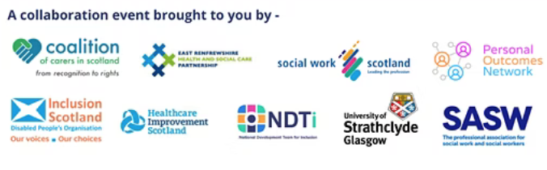

Eligibility Criteria: Exploring Alternatives
Monday 20th June

Session1 | 10.30am - 12.30pm
Session 2 | 1.30pm - 3.20pm

Agenda

Session 1

10.30am Welcome and the purpose of the session

10.35am Graham Kilpatrick – Midlothian Council
- Midway approach – trauma informed, outcomes focussed and strength based work
- Public accountability – managing the public purse
- Is this about there aren’t enough resources or the money being spent wrongly?

10.50am Adam Devanapis – Neath Port Talbot – Wales
- Whole system approach including changing resource allocation panels
- Step through commissioning process
- Autonomy of social workers and positive impacts on the workforce

11.10am Question and Answer Session with speakers

11.30am Discussion Groups

12.15pm Key messages

Session 2

1.30pm Lucinda Godfrey - Dundee Carers Centre
- The role of the third sector in providing support
- Moving away from eligibility thresholds and reducing bureaucracy
- Autonomy of support workers and co-production of solutions with carers
- Outcomes for supported people, carers and local authorities/HSCPs
1.50pm Mark Smith – Gateshead – England
- Moving away from traditional model of eligibility thresholds
- Personal and financial cost of having a crisis management approach
- Benefits and value of earlier intervention

2.10pm Question and Answer Session with speakers

2.30pm Discussion Groups

3.10pm Final messages and next steps

3.30pm Close

