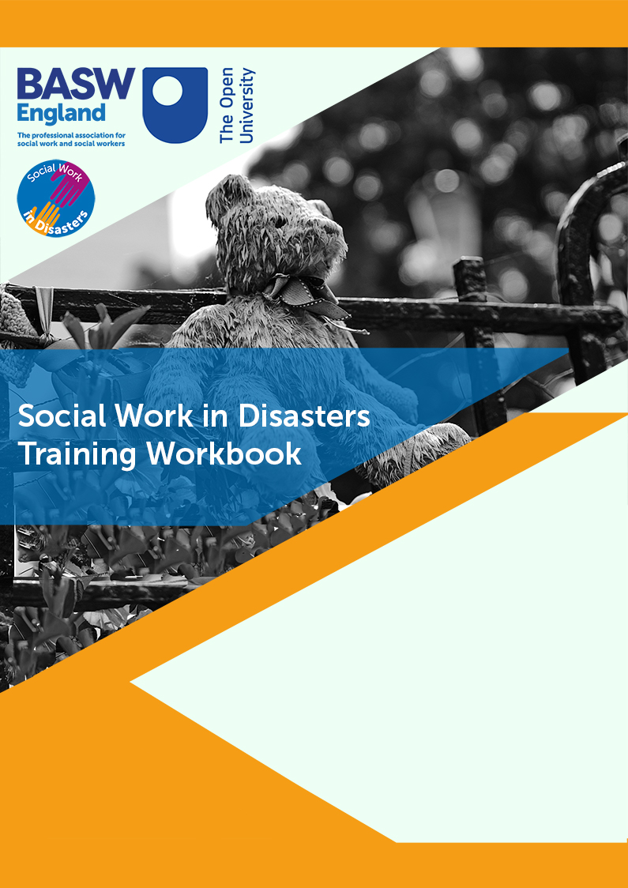

Social Work in Disasters Training Workbook

Module 1: Introduction to Social Work in Disasters

Short Tasks (Each task starts on a new page)

Short task 1 (15 minutes ⌚)
Below are three incidents that would meet the definition for disaster. Choose one, read more about it, and identify the hazard, the vulnerability and the insufficient response in this case.
Aberfan Landslide 1966
Hillsborough Stadium Disaster 1985
Manchester Arena Bombing 2017
Disaster:

Hazard

Vulnerability

Insufficient response

Short task 2 (5 minutes ⌚)
Search the internet for another disaster, or choose another disaster you are already aware of, to identify the Hazard, the vulnerability and the insufficient response.
Disaster:

Hazard

Vulnerability

Insufficient response

Short Task 3 (15 minutes ⌚)
Watch the following video discussing the response to the 2008 Wenchuan Earthquake (5 minutes ⌚).

Identify aspects of the social work role under the following headings:
Preparedness | Response | Recover

Short task 4 (10 minutes ⌚)
After watching the above video, reflect on how you would have responded if asked to support people following the Grenfell Tower fire.

What skills could you have drawn on that you currently have?

Short task 5 (15 minutes ⌚)
Based on the box above, are there any skills that you still think you need to develop in order to be an effective disaster informed social worker? Create a short plan here for two skills:

Short task 6 (10 minutes ⌚)
Consider people who you work with in your professional role who would be particularly impacted in the event of a sudden disaster. Why would this be the case?

Write two reasons:
Vulnerable group | Reason for vulnerability | Reason for vulnerability

Short task 7 (15 minutes ⌚)
Read the case study of Grenfell presented in the module. Pick a specific quote, and reflect on how a social work response could have better supported in that instance.

Write three ideas:
1
2
3

Module 1: Follow up Task
Based on your earlier reflection about who may be vulnerable to a disaster in your area of work, and the additional learning provided in this module, use whatever resources and contacts that are available to you to find out whether there is a plan in place to support them within your organization should there be a disaster of any kind. If there is a plan, find out what this is, and if necessary suggest some improvements, or take the initiative to publicise this within your team. If there is no plan, propose that one is developed, and use your learning here and from the other modules to lead or feed into this process.
Some ideas for developing this plan can be found here.

Write a brief reflection on your experience of undertaking this follow up task:

Module 2: Law, Policy and Best Practice

Short Tasks

Short task 1 (15 minutes ⌚)
Before moving on to consider the law that is specific to disaster working, think about how a piece of legislation you use regularly would apply in a disaster situation (for example, a terrorist attack or severe storm). If you cannot think of a piece of legislation, choose one of the following:
Children Act 1989
Care Act 2014
Human Rights Act 1998
Mental Capacity Act 2005

Short task 2 (10 minutes ⌚)
Recall the definition of disasters from module 1:
Hazard + Vulnerability + Insufficient Response = Disaster

Compare this definition with the above definition of an emergency and highlight three key differences:
1
2
3

Short task 3 (10 minutes ⌚)
Choose a Category 1 responder and a Category 2 responder from the table above. Identify the role that they would each have in disaster response, and write a brief scenario where these two responders would need to work together:

Category 1 responder role:

Category 2 responder role:

Scenario showing working together:

Short task 4 (10 minutes ⌚)

Come up with three ways that you could advocate for the role of social workers in disasters following on from this training:
1
2
3

Short task 5 (15 minutes ⌚)
Choose one of the following disasters, read more about it and identify one contextual factor that impacted on the preparation, response and recovery as has been presented above for the Manchester Arena Bombing.
Hillsborough Stadium Disaster 1989
Haiti Earthquake 2010
Westminster Terrorist Attack 2017
Preparation | Response | Recovery

Short task 6 (10 minutes ⌚)

If faced with a largescale disaster, like an earthquake or a terrorist attack in the UK, what do you think would be the priority for recovery of each of these? Note: we are asking what you think they would prioritise, not what you would. First one is completed for you
Party | Priorities for Recovery
Family who lost their house | Immediate accommodation, loss of personal possessions, insurance situation, maintaining ties to their community etc.
Mother whose son died
Small business owner who lost their business premises
Private construction company
Social work manager
Homeless person living in the area
International hotel chain that owns a hotel that was damaged
The local church
The Prime Minister

Module 2: Follow up task
Based on your learning from module 1 and 2, design a flyer that outlines the role of the social worker in a way that could be understood by other professionals and members of the public with ease. This should be designed to be used both before and during a disaster to spread this awareness. It may be advisable to return to Section 2 of Module 1 that gives a broad overview of the role of social workers in disasters. But remember, it needs to be accessible to those unfamiliar with social work jargon.
Following the development of this flyer, discuss with your manager/supervisor/colleagues about how it could be distributed.

Write a brief reflection on your experience of undertaking this follow up task:

Module 3: Person-centred and research informed practice within a multi-agency context

Short Tasks

Short task 1 (20 minutes ⌚)
Choose one of the following videos where survivors of disasters speak about their experiences.
Florida Shooting Survivors (6 minutes)
Hurricane Katrina Survivor (6 minutes)
Grenfell Fire Survivor (6 Minutes)

After watching the video, write a brief reflection on how listening to these experiences made you feel:

Short task 2 (30 minutes ⌚)
Watch this video about a survivor of the Manchester Arena Bombing (11 Minutes), thinking about the experience from a social work assessment perspective
Imagine you are writing an assessment of Amelia as a social worker. Use headings that you think are important in writing the assessment. Think about including details of her experiences, ongoing risks, strengths, support networks, other professionals involved, the wider context and anything else that you think is important. If possible, consider integrating social work theories into the assessment (for example, systems theory, strengths-based working, attachment theory).

Short task 3 (10 minutes ⌚)
In order to get you thinking about how research applies to specific groups and disasters,
Choose one of the following populations:
- Older populations
- Ethnic Minority Populations
- Women
And choose one of the following disasters:
- Terrorism
- Heatwave
- Flooding

Write three reasons why you think your chosen population may be more vulnerable to your chosen disaster:
1
2
3

Short task 4 (10 minutes ⌚)
Reflecting on the research that has been outlined in this section (Ngo, 2001, Barusch, 2011, Fernandez et al., 2002, Adhikari et al., 2018, Rivera et al., 2015) and drawing on your own knowledge and experience as a social worker, briefly outline some of the techniques that you think would be valuable in supporting/engaging older populations in the UK following a disaster:

Short task 5 (10 minutes ⌚)
Reflecting on the research that has been outlined in this section (King-Okoye and Underwood, 2020, Dominelli, 2013, Zakour and Harrell, 2004, Dako-Gyeke and Adu, 2017), and drawing on your own knowledge and experience as a social worker, briefly outline some of the techniques that you think would be valuable in supporting/engaging ethnic minority populations in the UK following a disaster:

Short task 6 (10 minutes ⌚)
Reflecting on the examples presented above (Alipour et al., 2014, Akerkar, 2007, Alston, 2013, Dominelli, 2020) what are some of the reasons why women in the UK may be more vulnerable to the impact of disasters?

Short task 7 (15 minutes ⌚)

Thinking about your own area of work/expertise, in the event of a disaster, what are the professionals who would be most important for you to collaborate with?

What barriers might exist to making this collaboration happen?

What preparation could you undertake to reduce these barriers?

Module 3: Follow up task
Get in touch with your Local Resilience Forum through whatever means are available to you (email, phone, social media, face-to-face). Ask them openly if they have social work involvement at the moment (think about sending them the flyer that you designed as part of Module 2). If they have no social work involvement, start a conversation about how they could include this perspective (check with your manager/supervisor as appropriate).

Write a brief reflection on your experience of undertaking this follow up task:

Module 4: Responding, using theory and self-care

Short Tasks

Short task 1 (10 minutes ⌚)
Identify three social work theories/models that you are aware of, or have used in your practice. Write a single sentence explaining how the theory could support working in disaster situations.

Theory 1:

Application to disaster working:

Theory 2:

Application to disaster working:

Theory 3:

Application to disaster working:

Short task 2 (15 minutes ⌚)

Pick an example of a case or situation from your practice/life, and apply this seven stage model to it, working through each stage one at a time. How would this perspective have helped you in that case?
1
2
3
4
5
6
7

How it may have helped:

Short task 3 (15 minutes ⌚)
Margaret lives alone in a flat in a large residential building in the middle of a busy city. She works part time as a dentist, but other than this largely keeps to herself. She is also currently taking medication for depression that she links with her history of sexual abuse as a child. Yesterday Margaret was in a train crash on her way home from work, where three people died and a large number were injured. Margaret was seen by paramedics at the scene and found to have no serious physical injuries. She was offered the opportunity to go the hospital to receive further assessment and support, but declined this. However, due to her disclosure of depression during the assessment at the scene, the paramedic sends a referral to your team. You phone her and Margaret agrees to meet with you, but you can tell she is reluctant and unsure. She was also clearly upset during the phone call when you asked specifically about her mental health.

Imagine you are a social worker who is asked to respond to the above scenario. Choosing either crisis intervention theory or trauma informed social work, explain how you would support this individual.

Short task 4 (20 minutes ⌚)
This activity is designed to get you thinking about creative responses to disasters that you could employ, as well as the complex nature of disaster working that necessitates these types of responses. Take the examples below, and provide one creative response that you think you could use to support those involved. There is no right or wrong answer to these scenarios, but start to think about underpinning your response with social work values and ethics (more on this in the next section).
Scenario 1: Poonam is a 35 year old mother of two. Her children are both in the local school when a significant section of the school collapses. You arrive at the chaotic scene and find her outside, very upset, and asking person after person if they have seen her children, with no response.
Scenario 2: The Juarez family (mother, father and two sons) have just arrived in the UK as refugees, escaping religious persecution in their country of birth that had led to the death of several of their family and friends. The accommodation they are placed in is targeted in a terrorist attack by an anti-immigration organisation who set the building on fire. After this experience, you are brought in to support the family, and the father of the family discloses to you that they are thinking about returning to their country of birth after the experience. He also says that he spoke to a helpful government employee that morning who has encouraged them to return to their country and even suggested that the government would pay their flights.
Scenario 3: You arrive at a community centre where a large group of residents have been evacuated to after serious flooding. A woman approaches you stating that she is in need of sanitary products for herself and diapers for her child, and that none of these are currently available. The centre appears to be run by volunteers who state they can only distribute what they receive.

Short task 5 (20 minutes ⌚)
Read through The British Association of Social Workers Code of Ethics and identify two ethical principles from the code that you think are particularly applicable to social work in disaster contexts. Explain your reasoning and how they relate to your learning on this course so far.

Ethical Principle 1

Ethical Principle 2

Short task 6 (15 minutes ⌚)
Choose one of the two examples outlined above (care home discharges during Covid-19 or emergency support planning for disabled residents in Grenfell Tower) and, applying social worker ethics, suggest three strategies that social workers could have used to challenge these practices.

Strategy 1:

Strategy 2:

Strategy 3:

Short task 7 (15 minutes ⌚)
What other support may be important for you to support you in managing a disaster?

Outline two factors not discussed in the above table:

1.

2.

Short task 8 (25 minutes ⌚)
Develop your own self-care plan. The headings provided here should be taken as a guide only, and you can include whatever strategies and information that you feel is pertinent to your own requirements.

Who can I contact if I need to talk?

What support do I require from my employer?

What activities will I continue to engage with outside of work?

How do I access counselling support if I need it?

If I am experiencing a particularly difficult day at work, what strategies can I utilise to support me to get through the day? What support might I need at the end of the day, or the next day?

